TOUR FLOW:

1. APPLICATION GENERATES ERROR FOR HTML TAG WHEN USER ENTER THEM IN ITINERARY

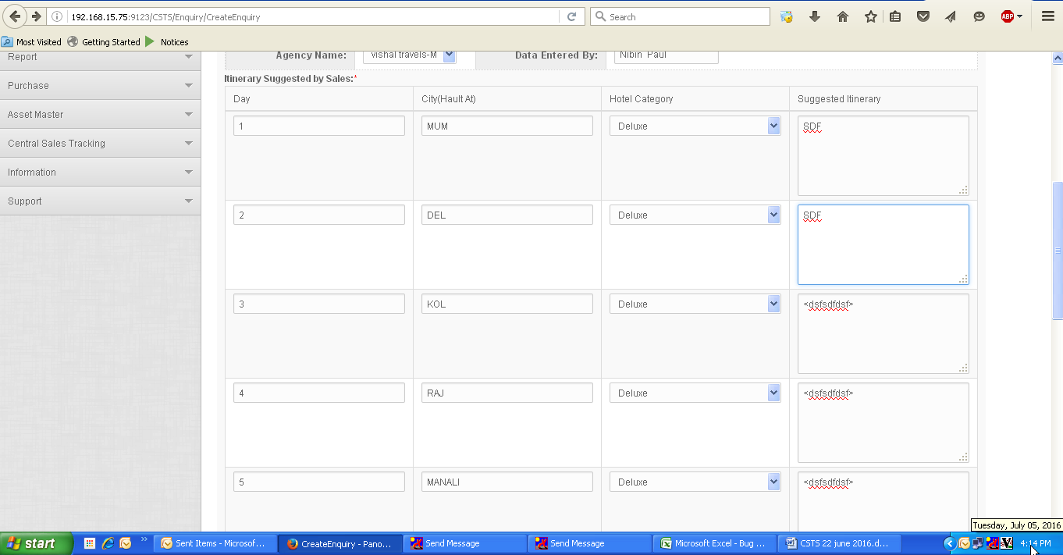

2.FOR VERSION-2 , IF USER EDIT DATA FROM 5 TO 3 DAYS, TOUR DURATION, STILL APPLICAITON DISPLAYS 5 DAYS DATA IN VERSION 2.

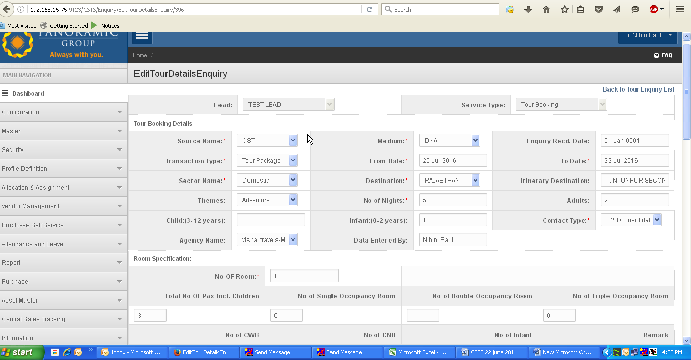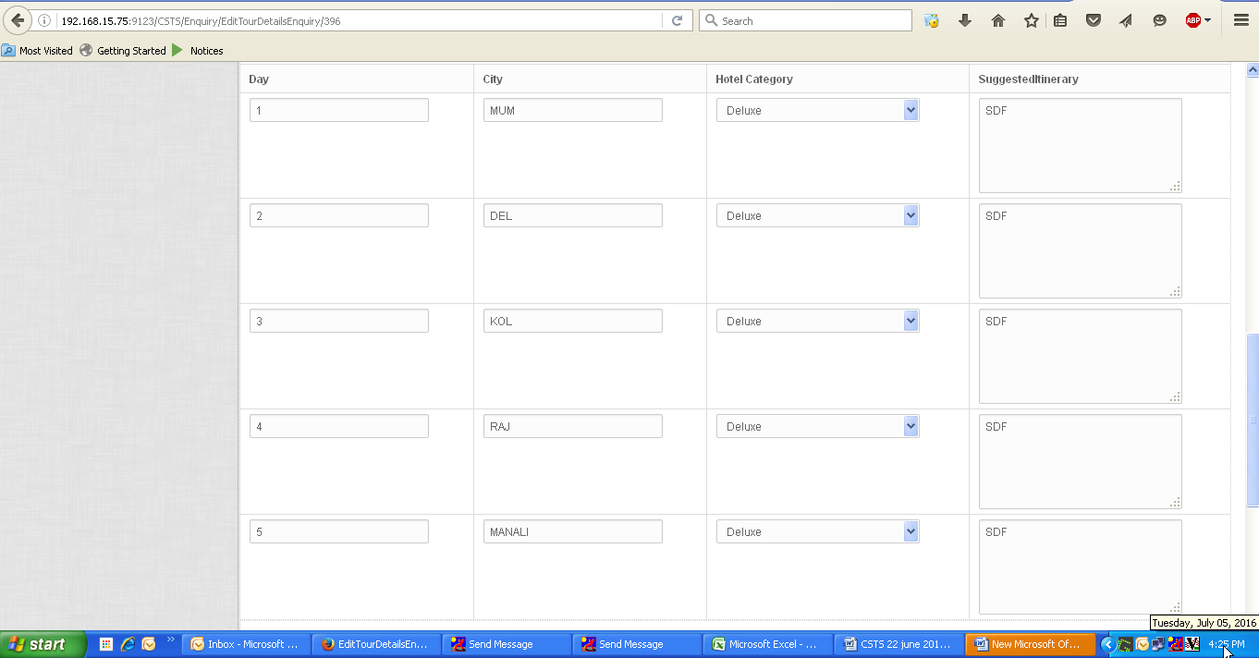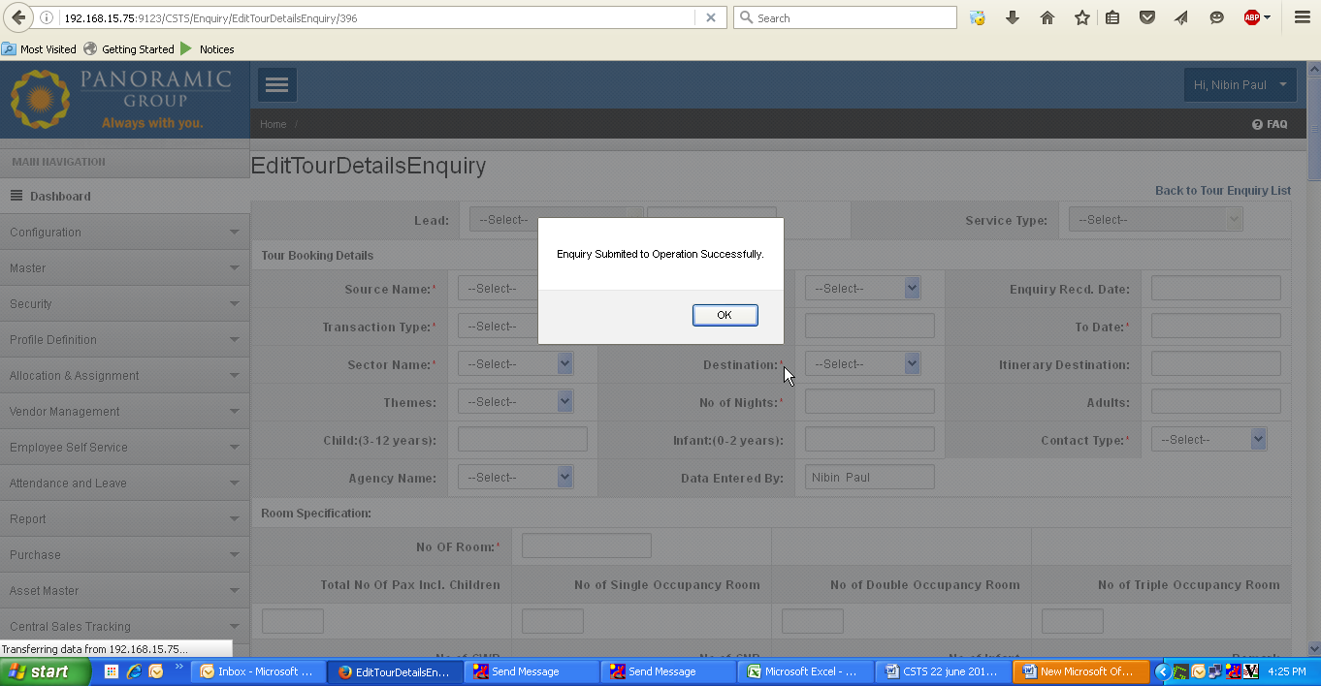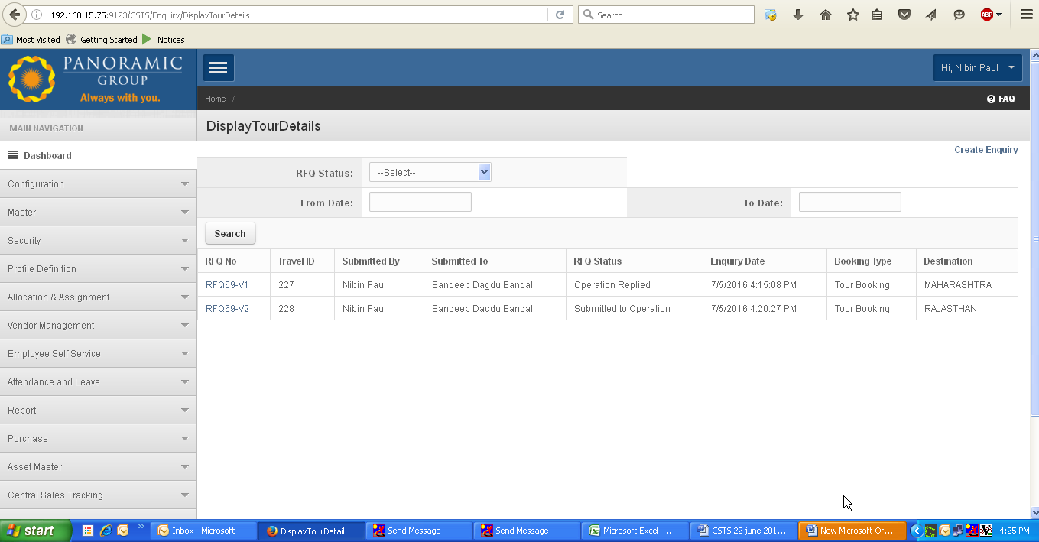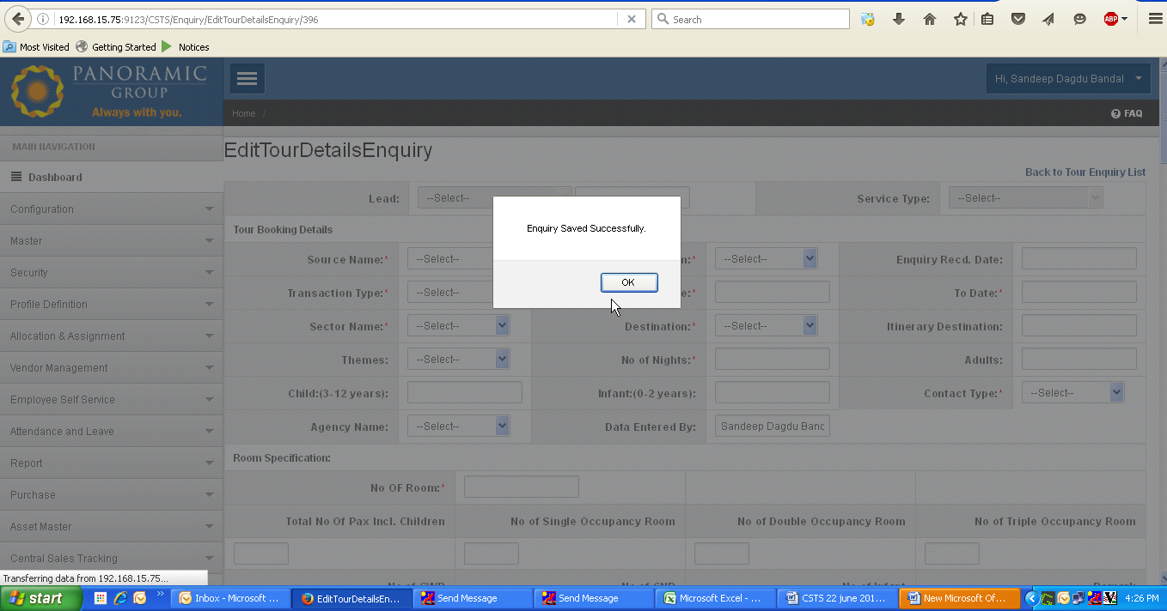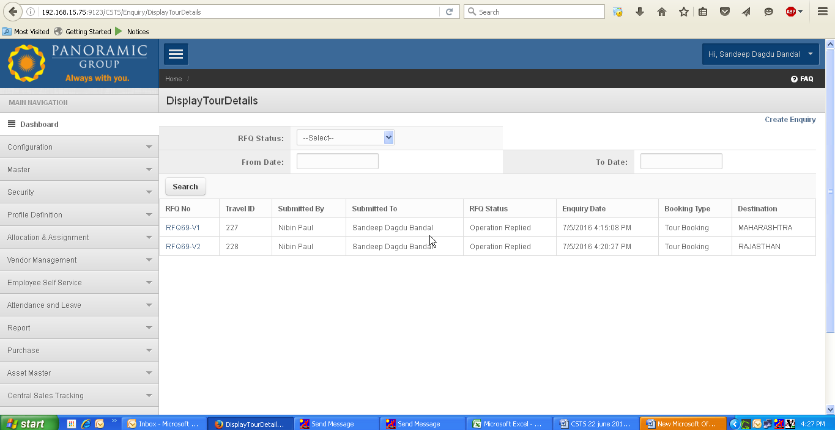

3. Application allow to submit to sales, even operational user not put any data in it as displays:

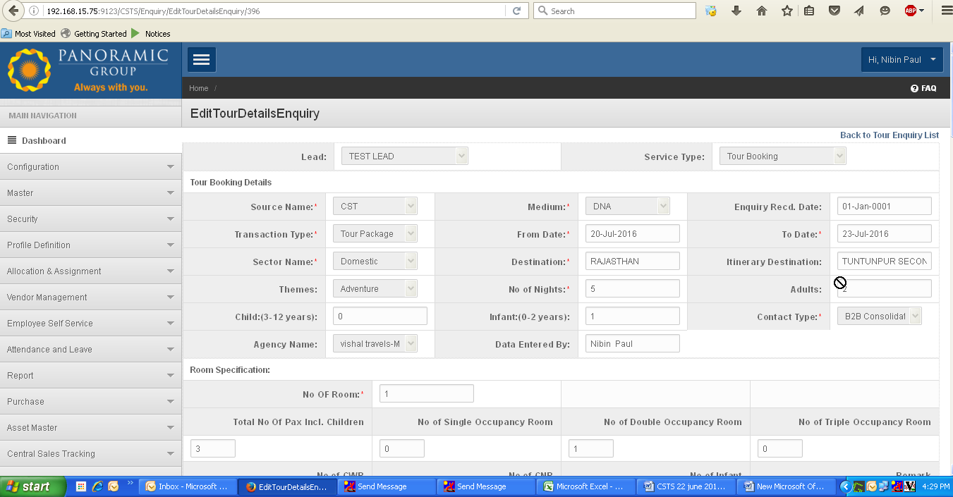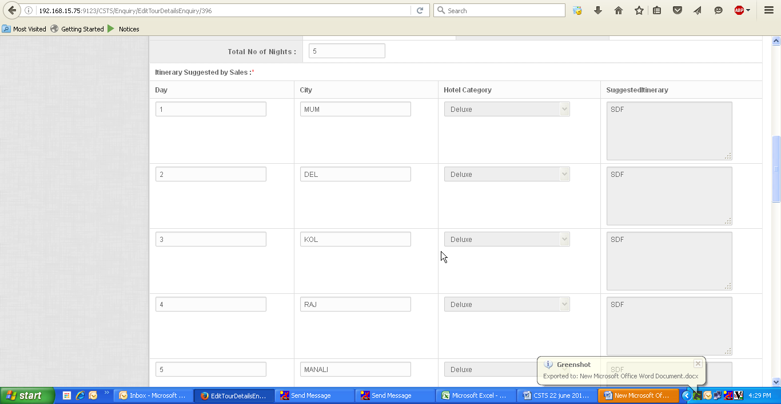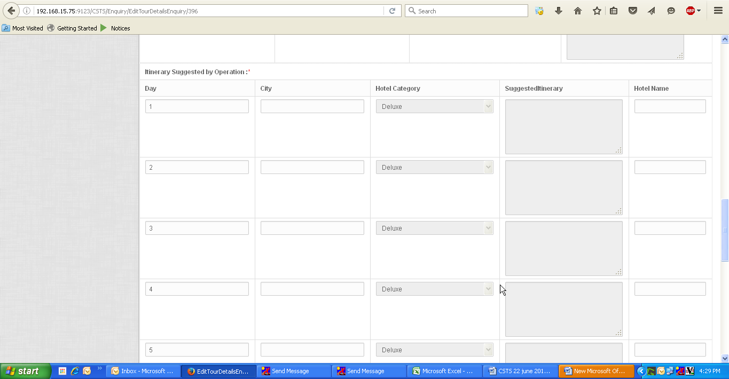

4. Search lead is not working: as lead with name “Vishnu” is created, still application not displays the lead when user use search option

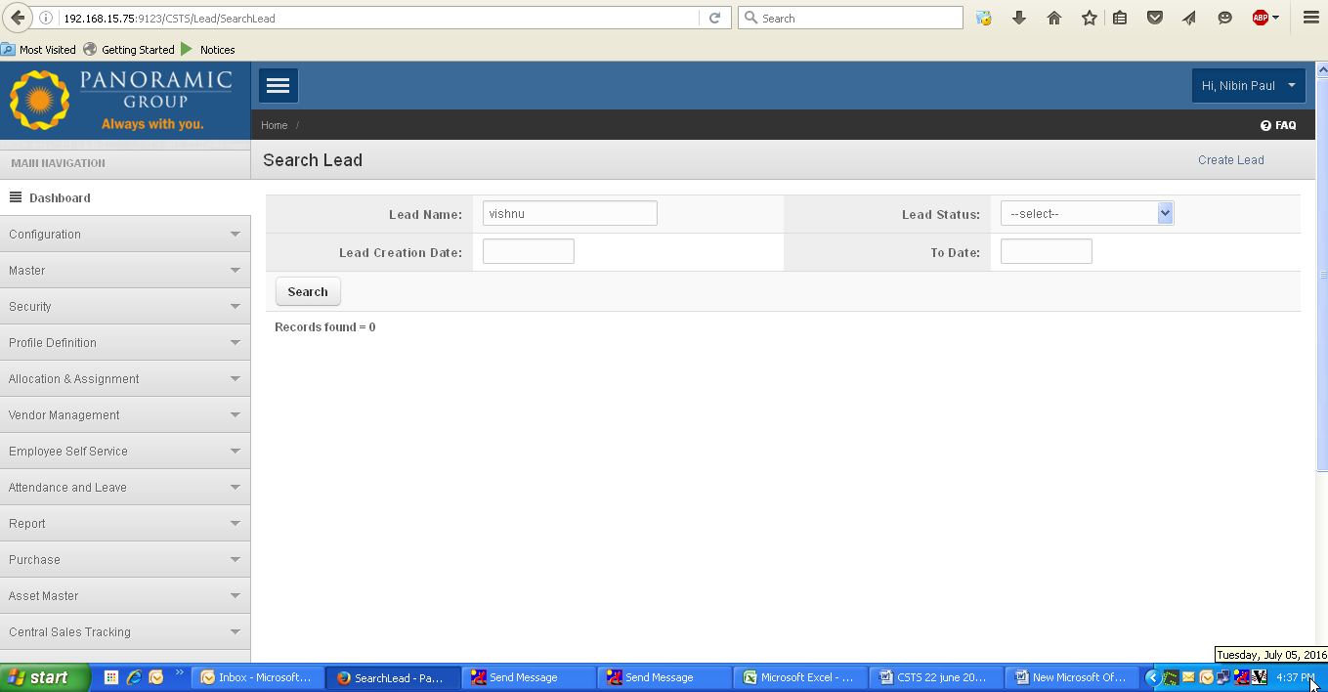

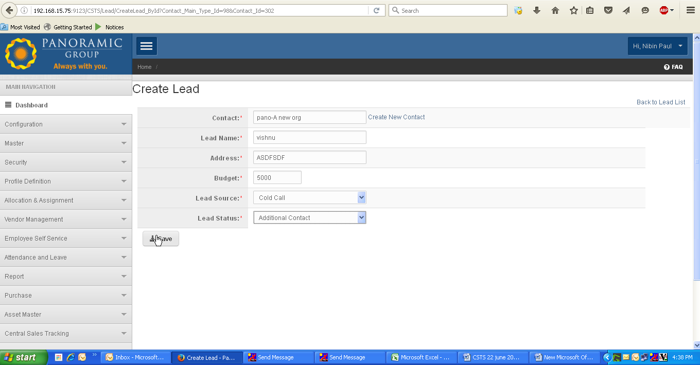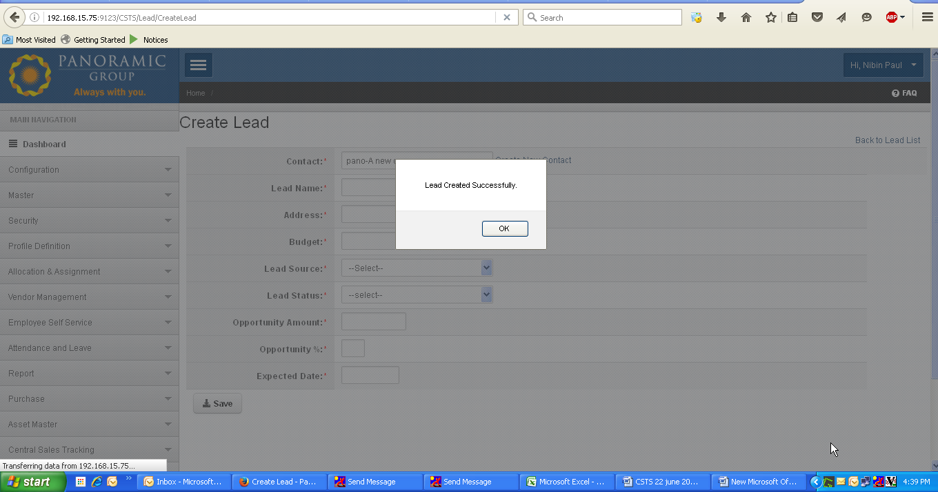

HOTEL:

5. Hotel login displays tour data

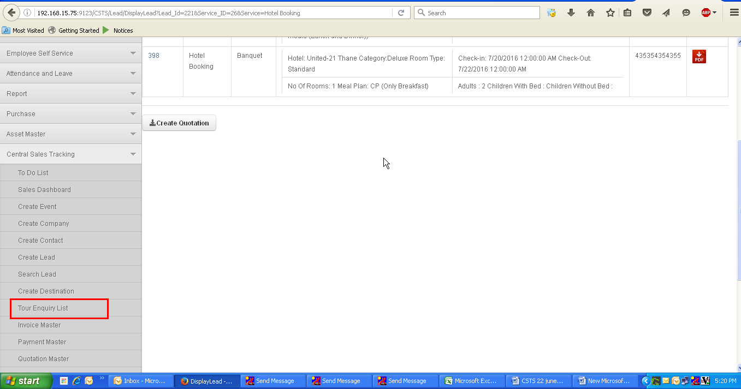

6. Create Quotation links creates error page, for already created quaotation.

Once quoation is created, then again go to quotation page , by menu🡪central sales tracking🡪 create hotel inquiry🡪 back to hotel inquiry page🡪 click on create quotation link( where quotation is already created.

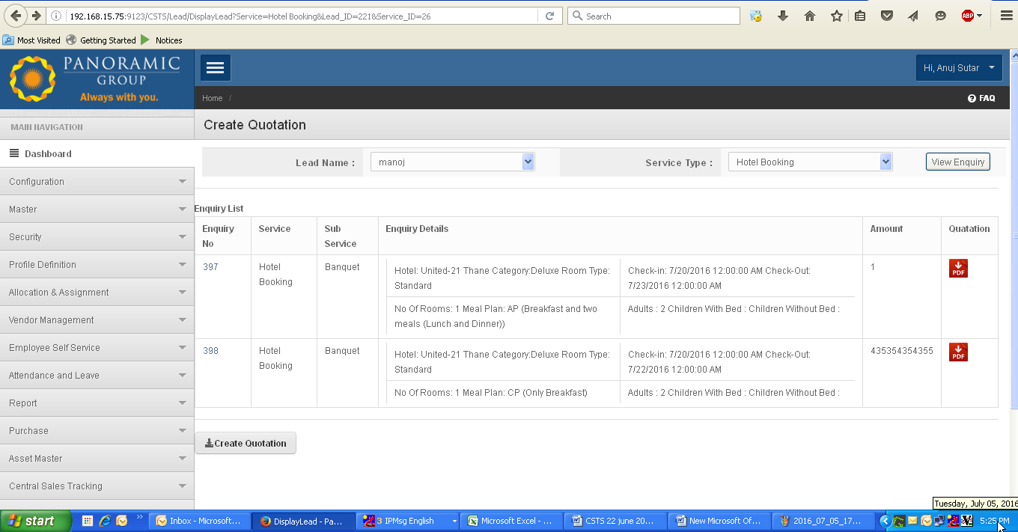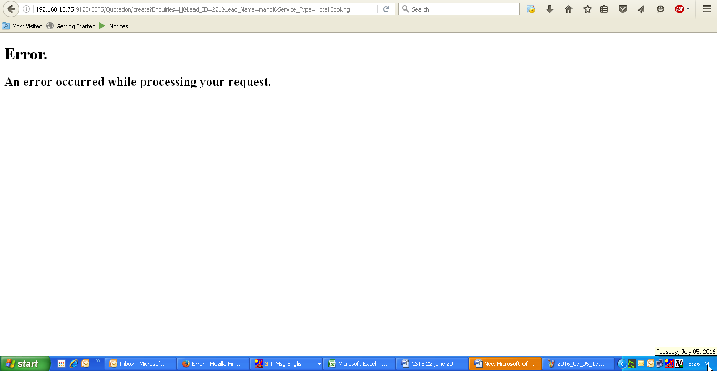

7. Found two menus for create event:

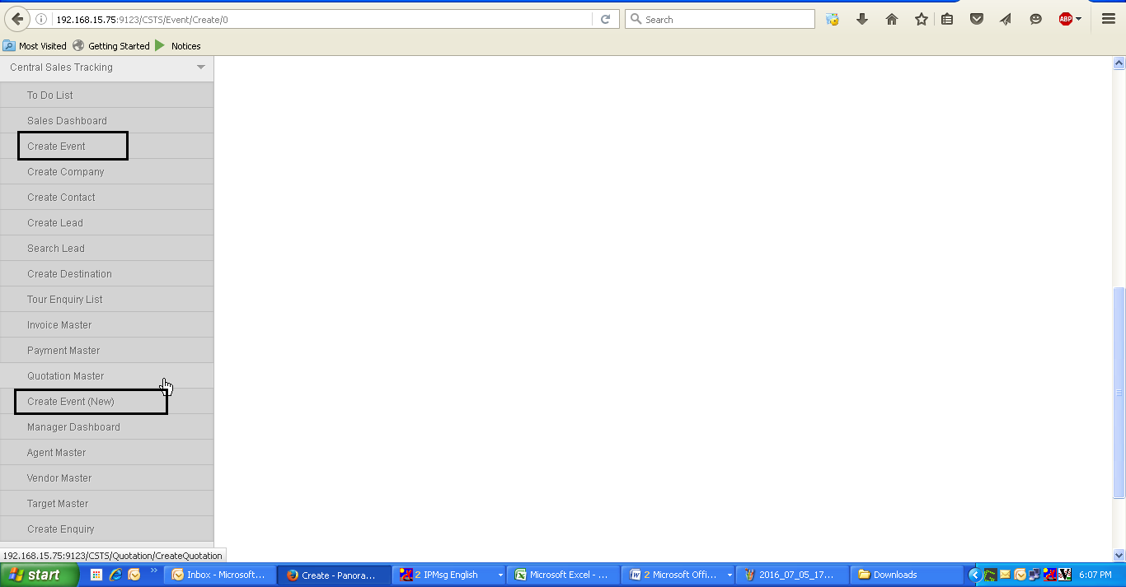

8. Once lead is created, application still displays contact person name on screen.

Contact field should be blank once lead is created.

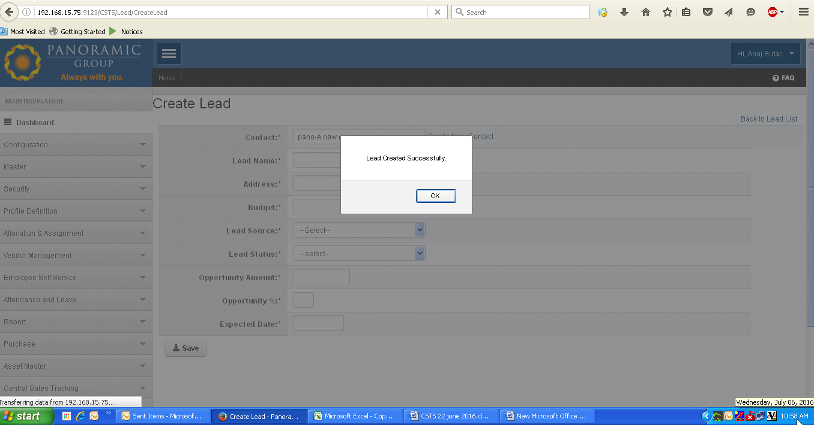

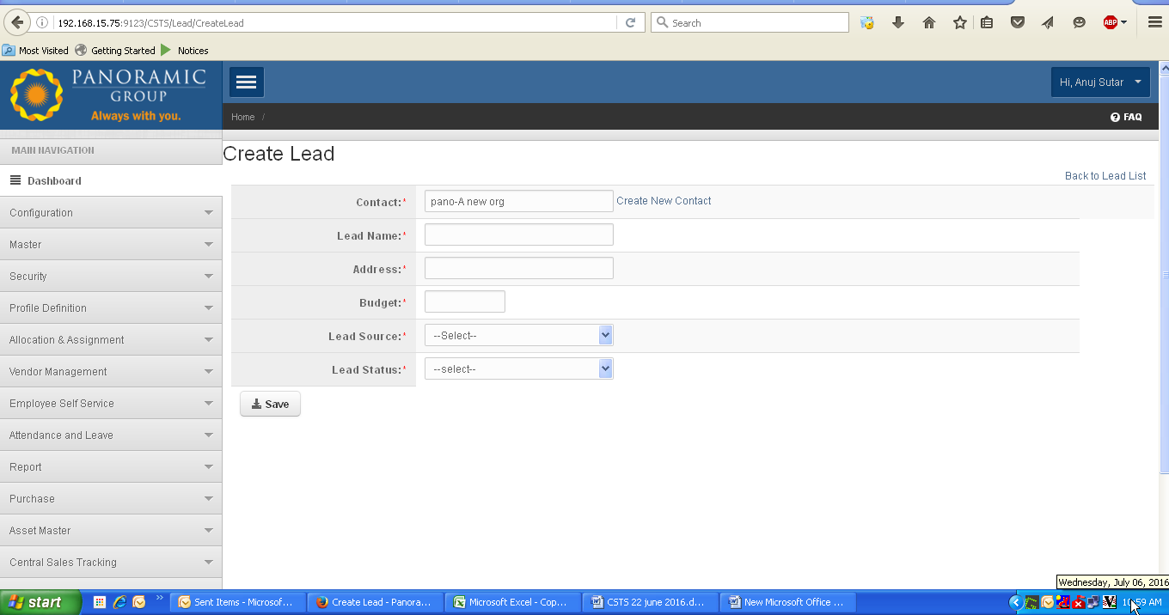

9. Back to lead: hyperlink redirects to search lead page: should be redirected or display created lead table When user click on back to lead, Redirects to following page

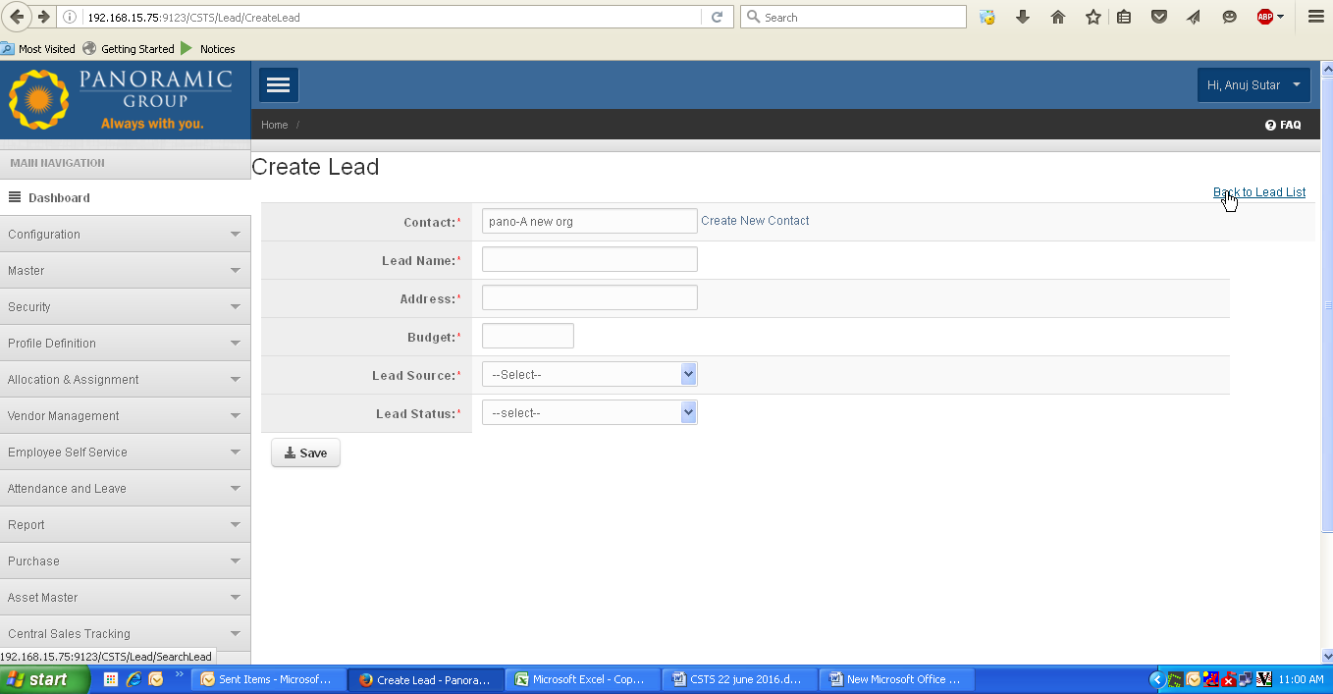

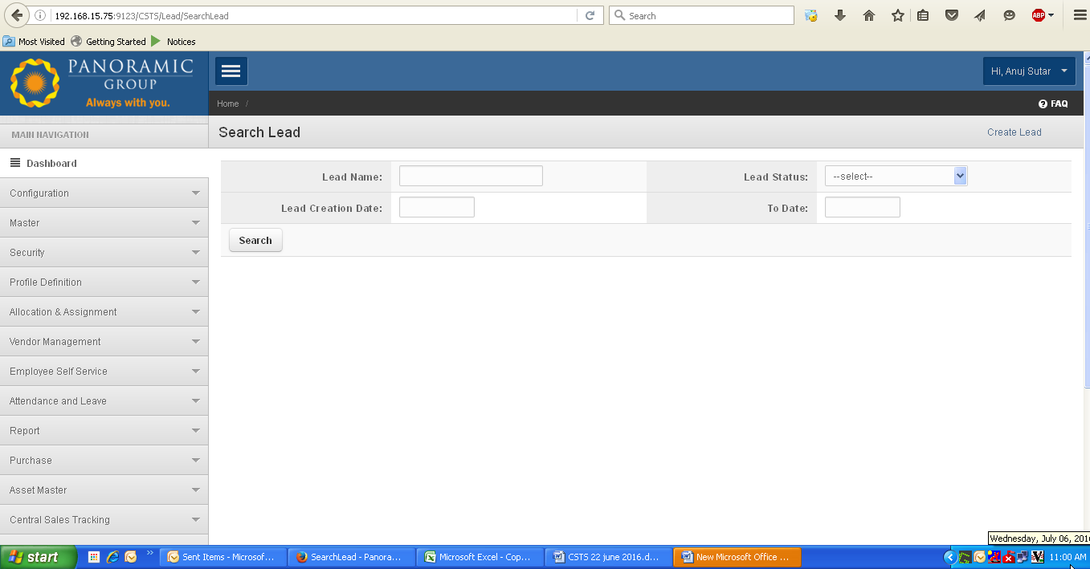

10. Application allows to create back dated events:

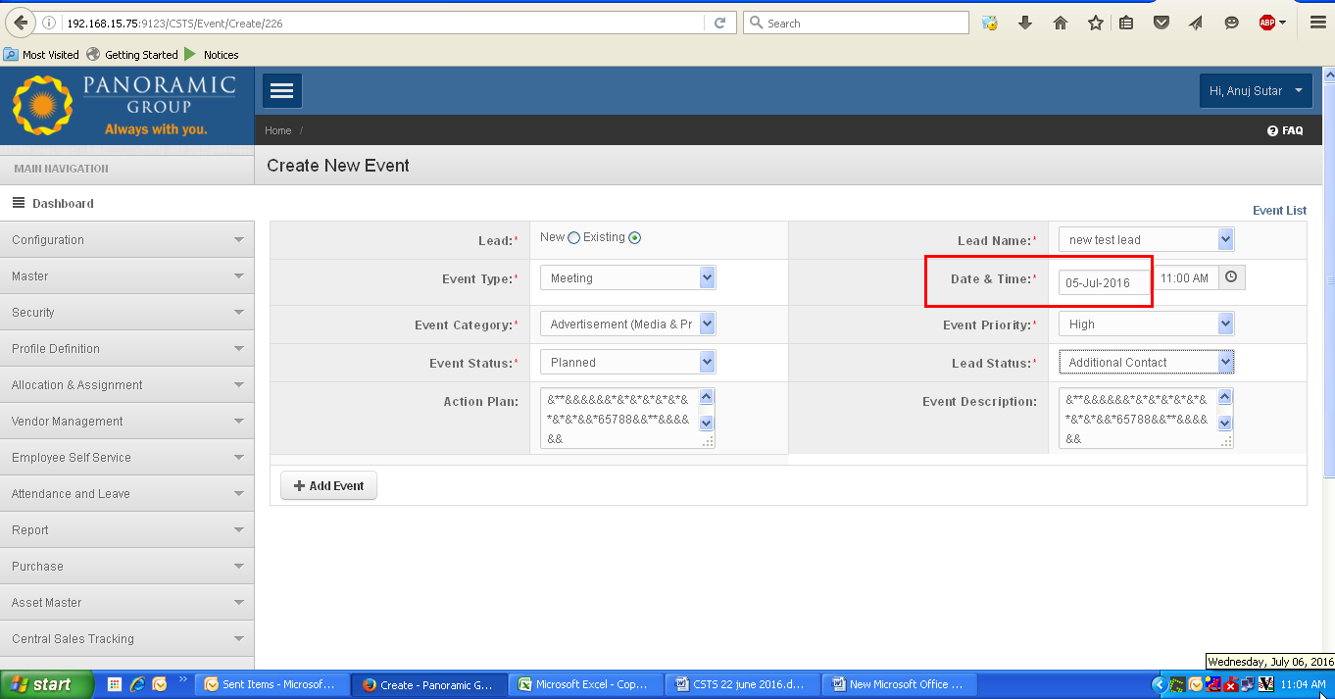

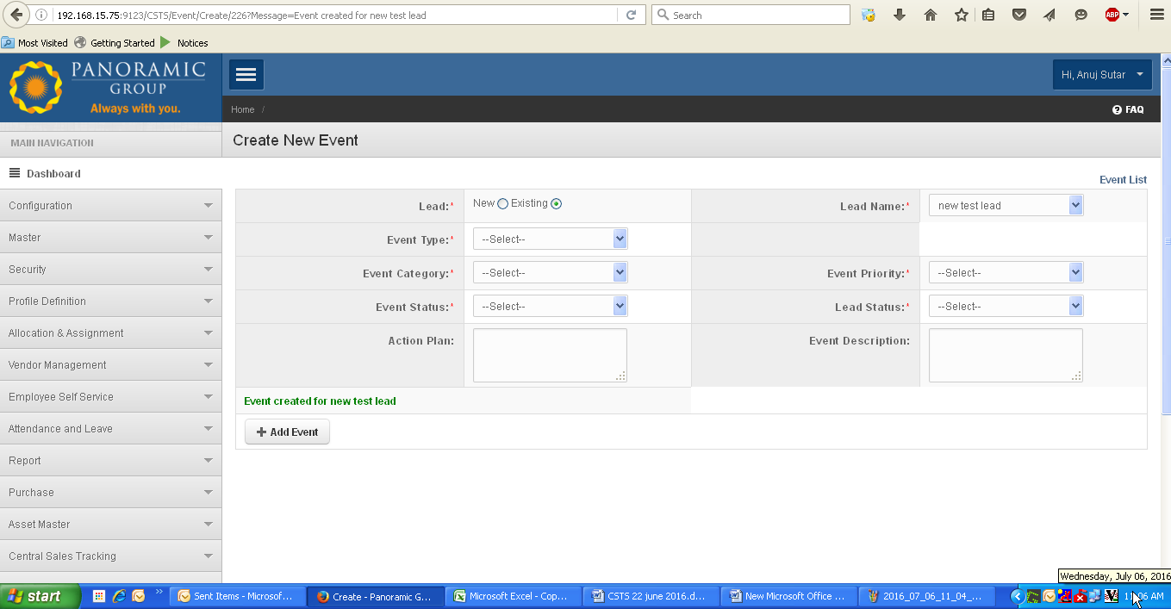

11. Need to implement horizantal scrollbar for event list:

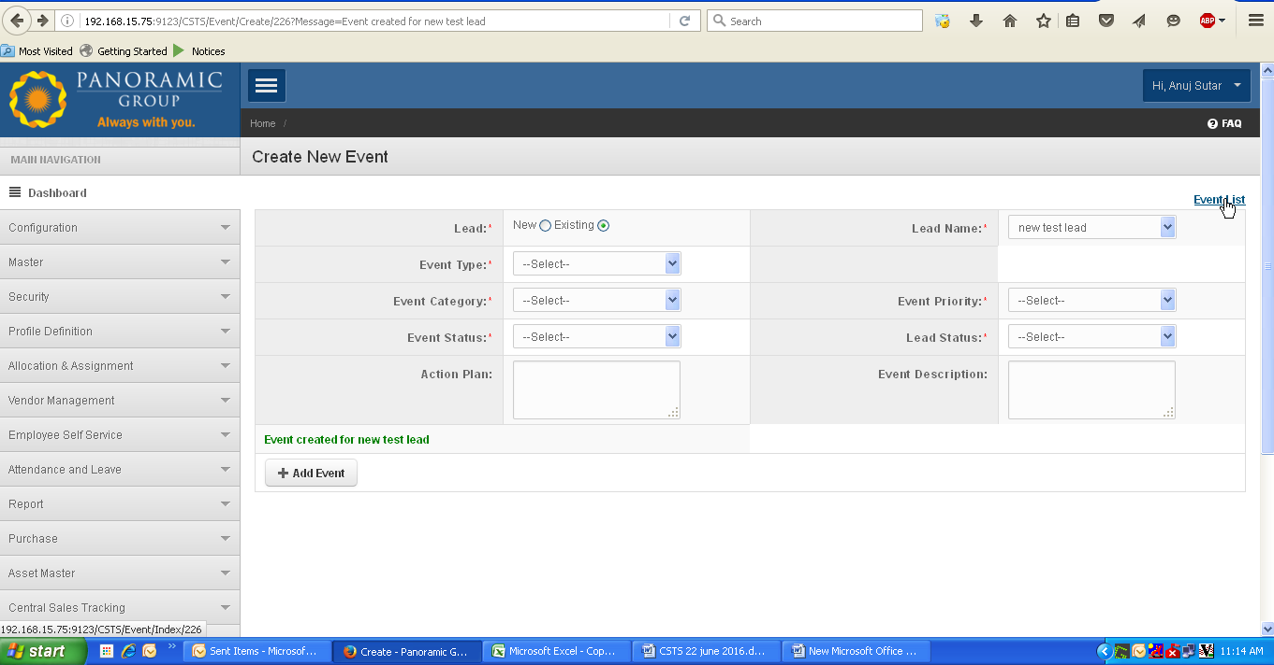

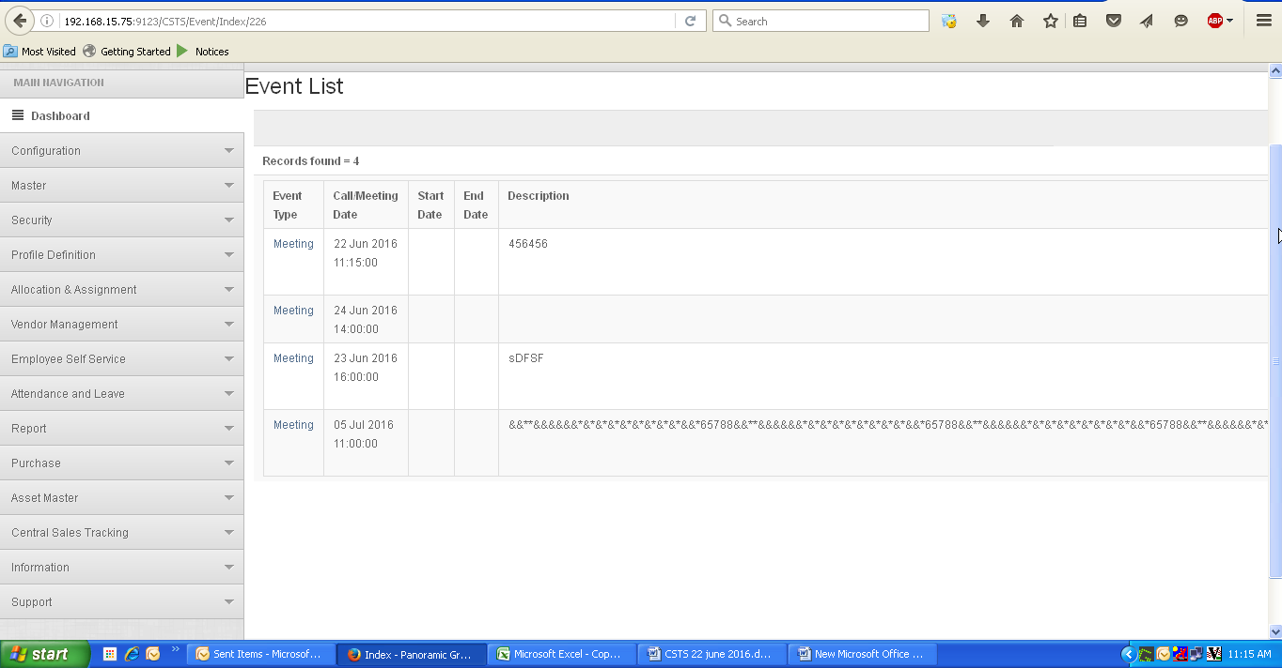

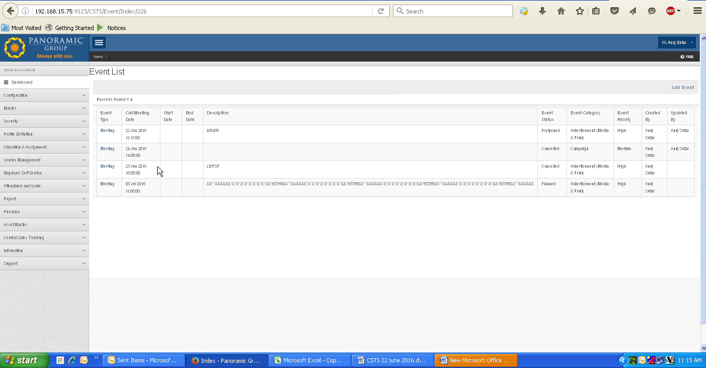

12. Event list: Application displays “Start date” and “End Date” columns as blank.

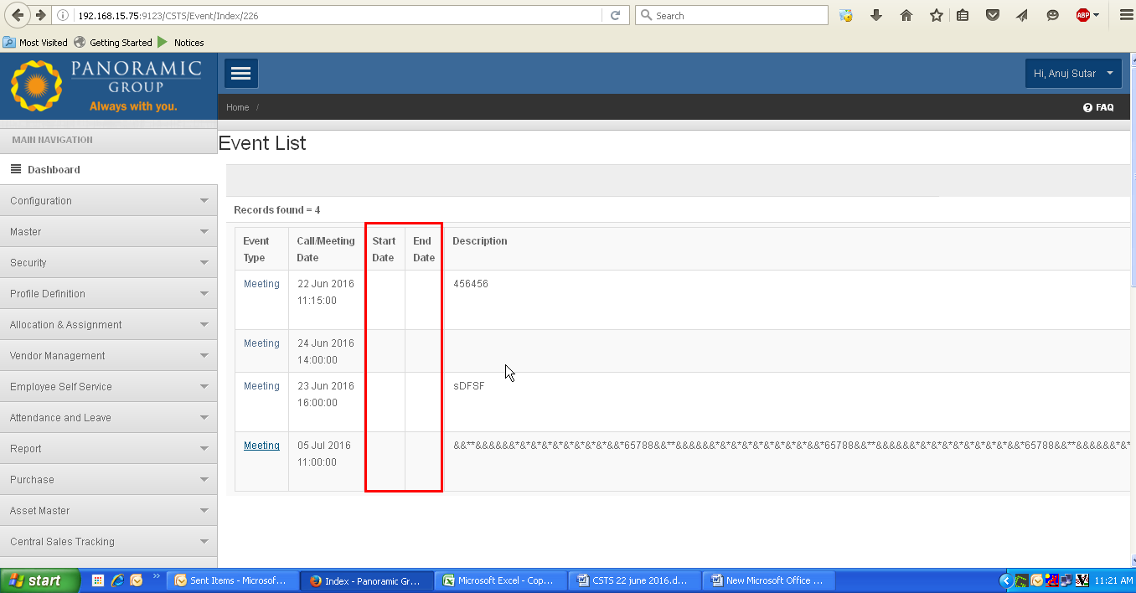

13. Create enquiry: when user change the dropdown of “Query sub status” from “inprocess” to any other status say “confirmed”(you can select any), and again select the “Inprocess”, application not displays “sale amount” and “Sale date” field as shown.

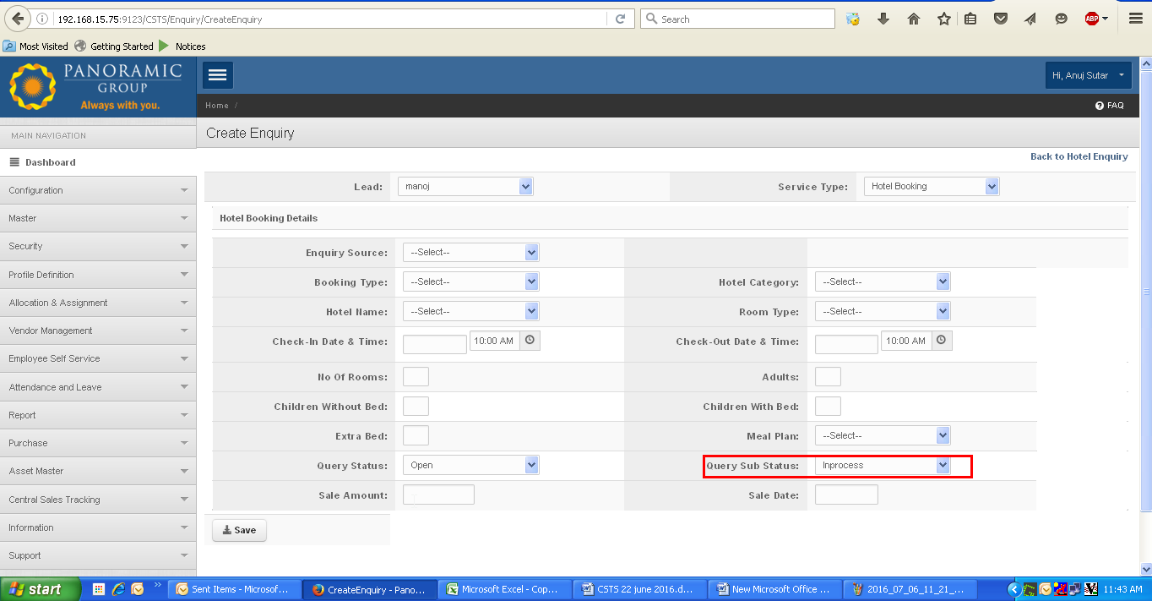

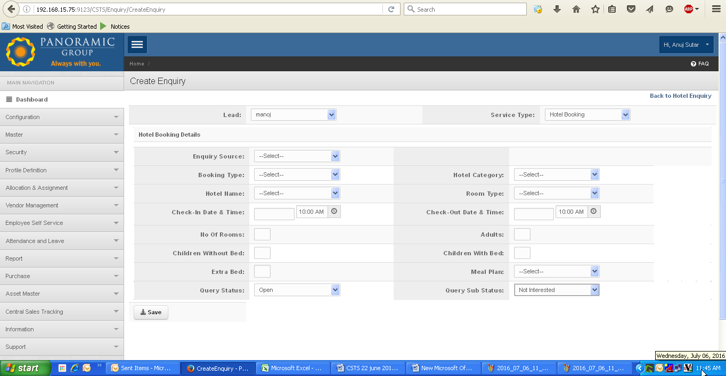

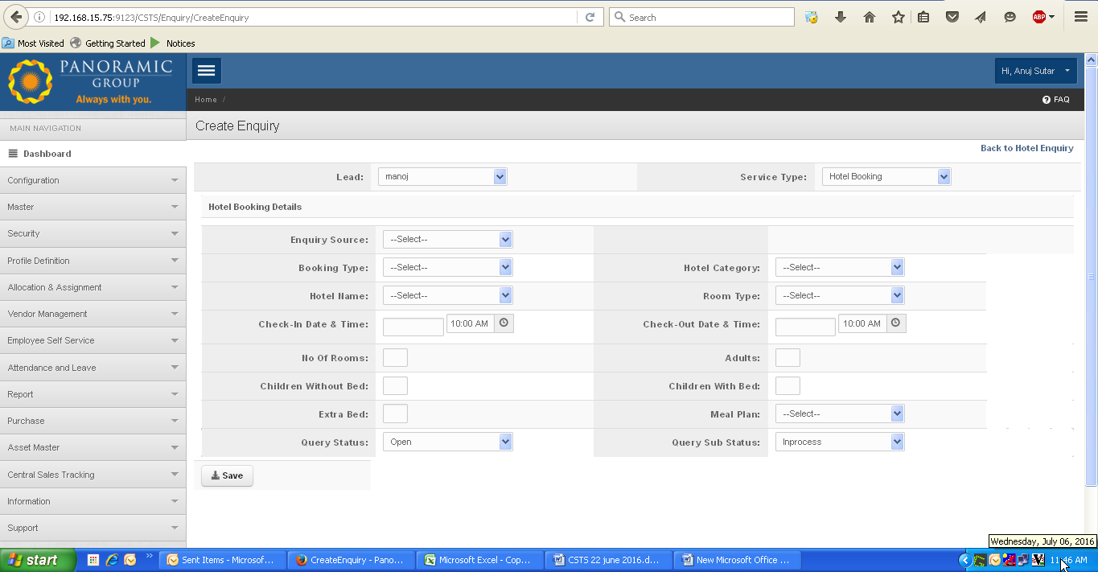

14. Create Quotation: From create quotation page when user click on “Enquiry no” hyperlink, (for edit mode), application not displayes entered amount for “sale amoun” and date for “sale date”

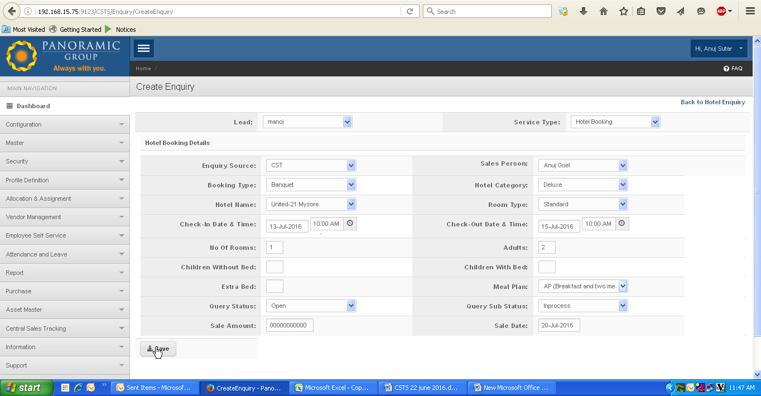

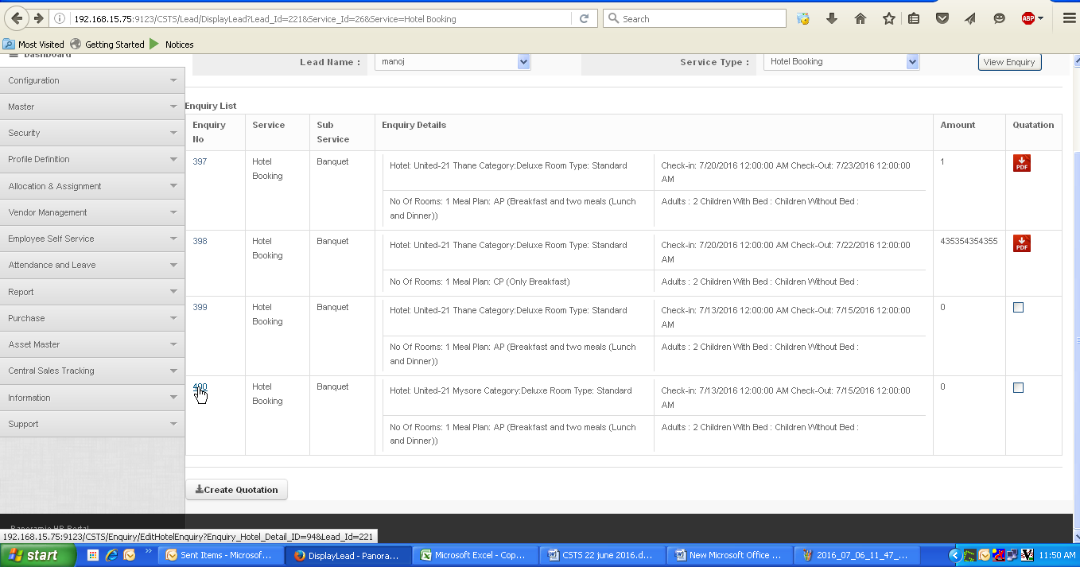

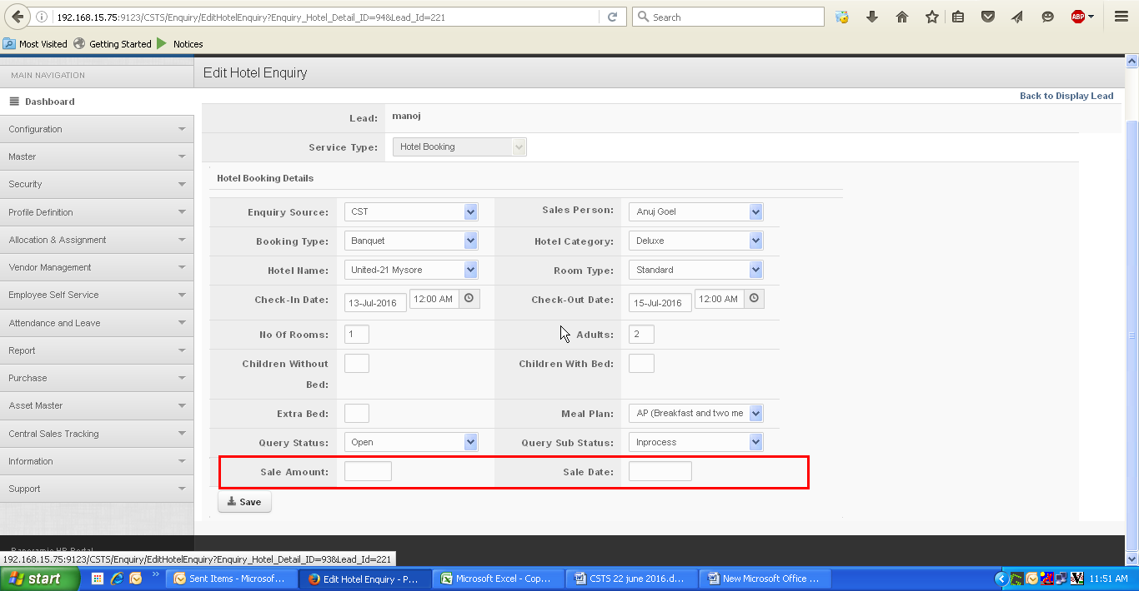

15.Quotation pdf: Amount is not displayed in proper format.

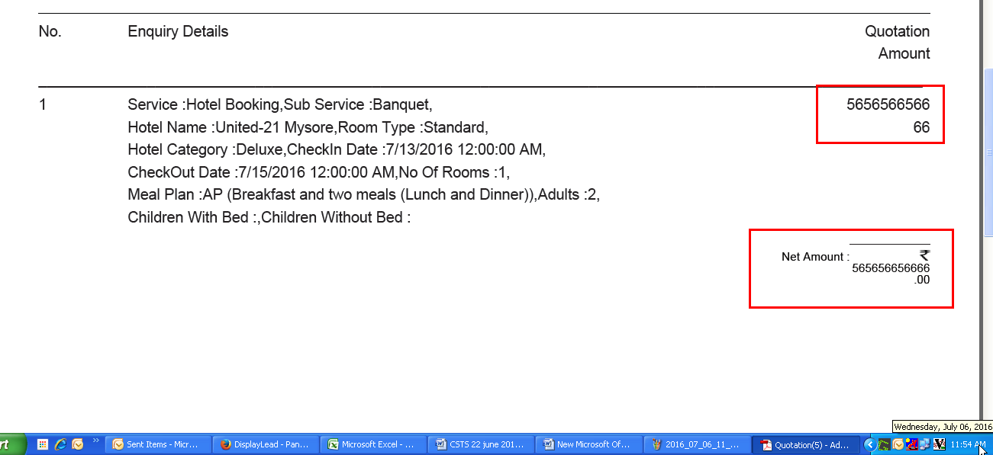

16. Control should be properly implemented for “Hotel Enquiry” page.

When user click on “Back to hotel enquiry” hyperlink, application redirects “Create quotation” page as per requirement, but application auto select the lead name and screen displays “No record found” message. (By default lead name value should be “selected”)

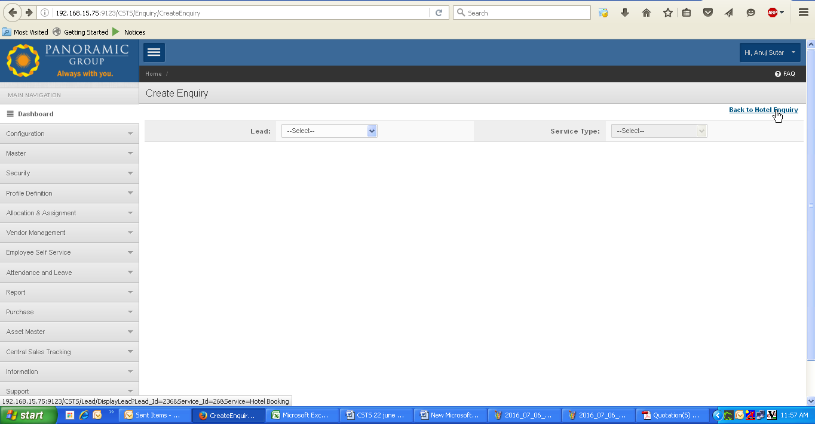

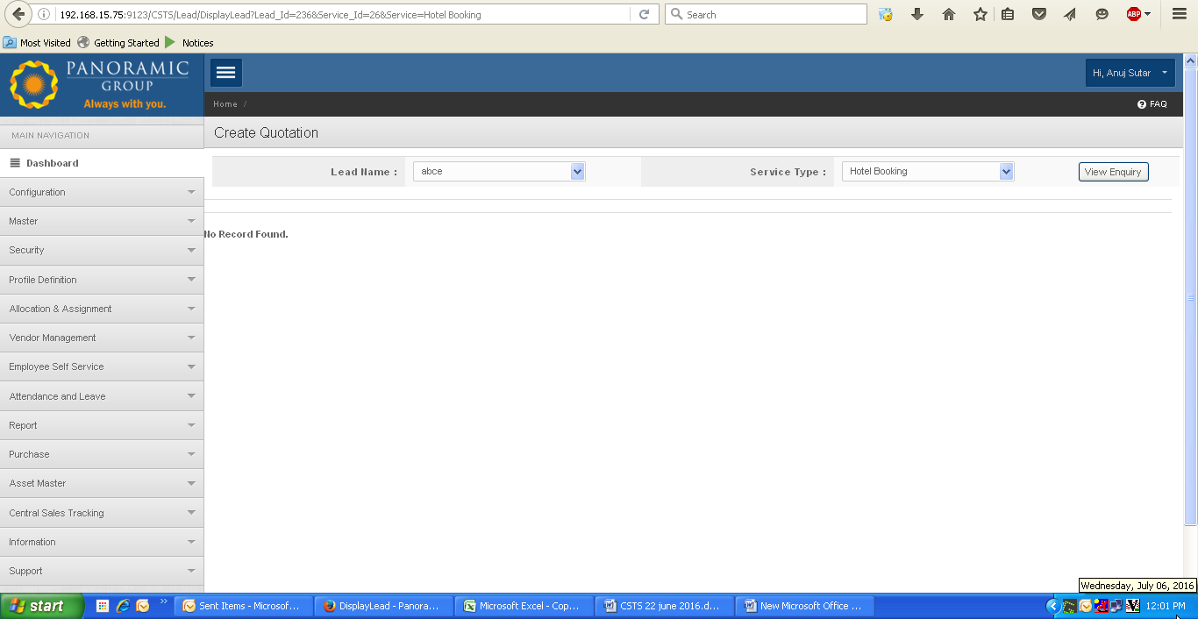

17. Event: When user create event applicaition allow to enter some special characters as shown below, but while updating same data application displays warning pop up message “Special characters not allowed”

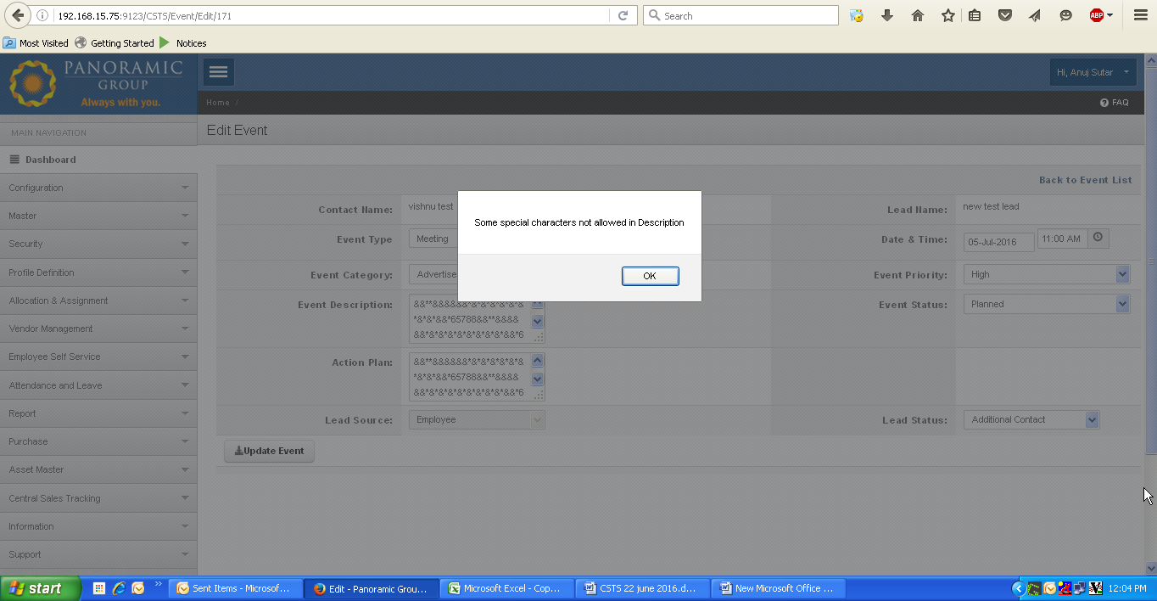

18. Need to implement mandatory marks for each form wherever required, here on “Create Enquiry” page.Where initially application does not display the mandatory marks, but when user click on “Save” button it displays warning messages about mandatroy fields.

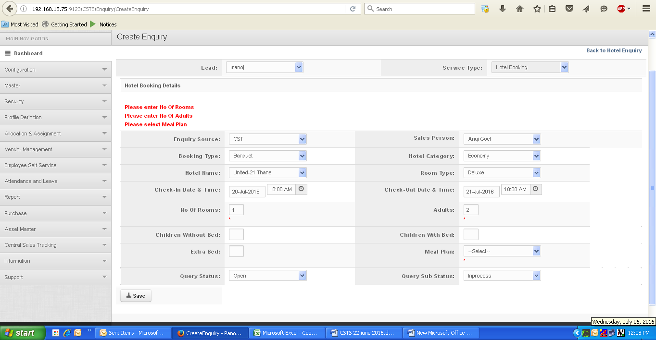

19. Application allow to enter “0000000000” value in contact no.

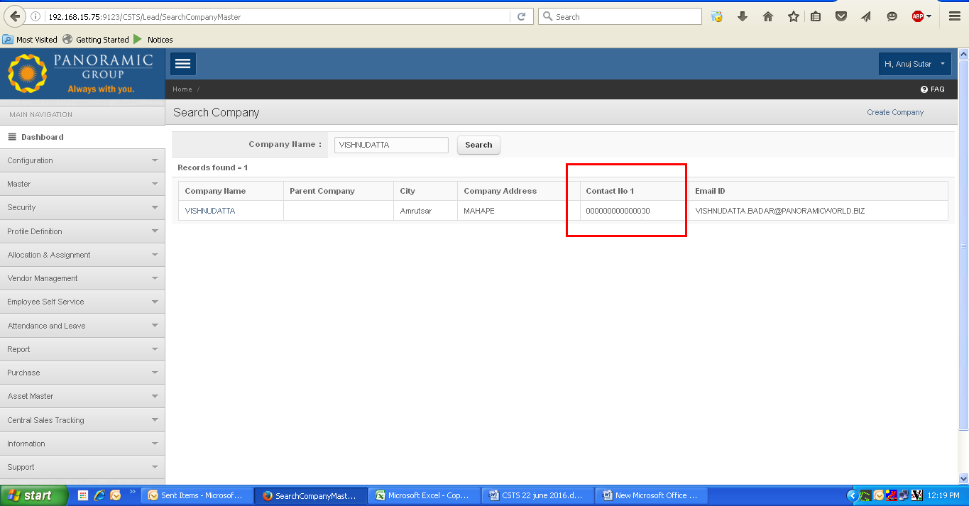

20. Create company: when user tries to update by clicking on company name link (for edit mode),

Application automatically selects the “parent company name “as displayed.

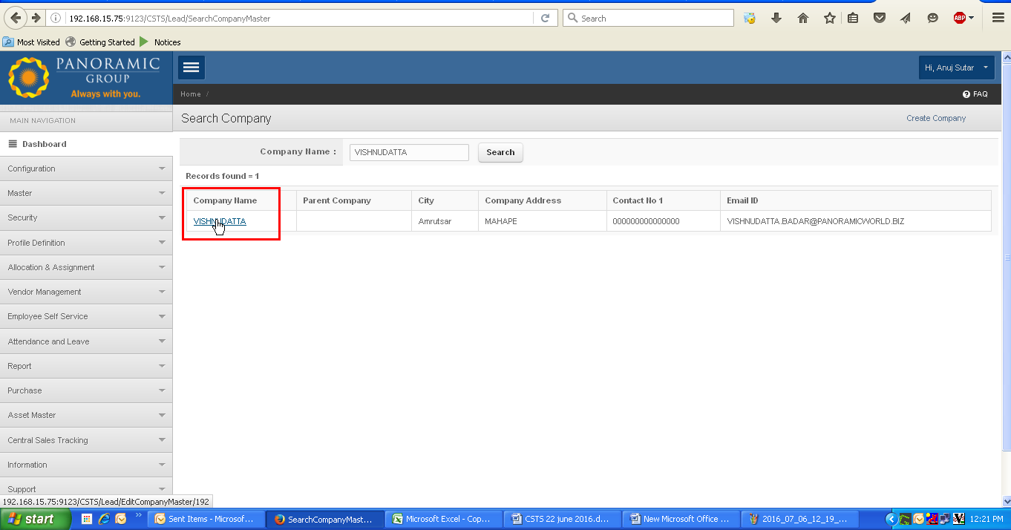

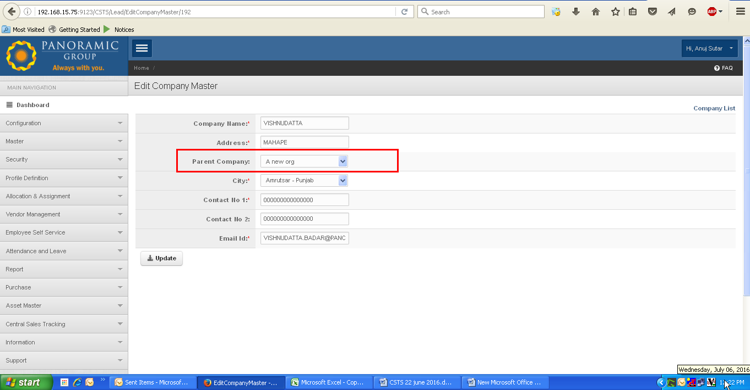

21. Error page generated for “Edit lead” section, when user change the status of lead.

For following change from “Additional contact” to any and click on update.

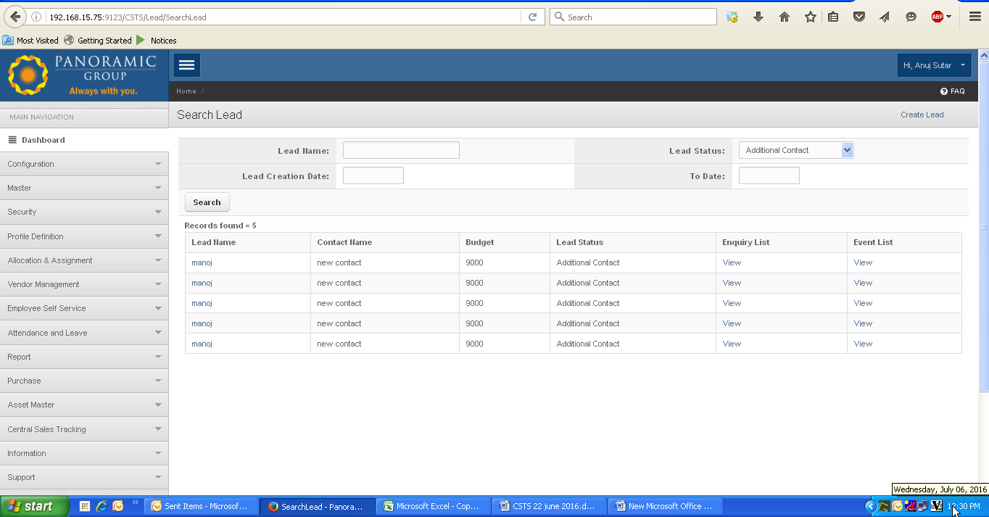

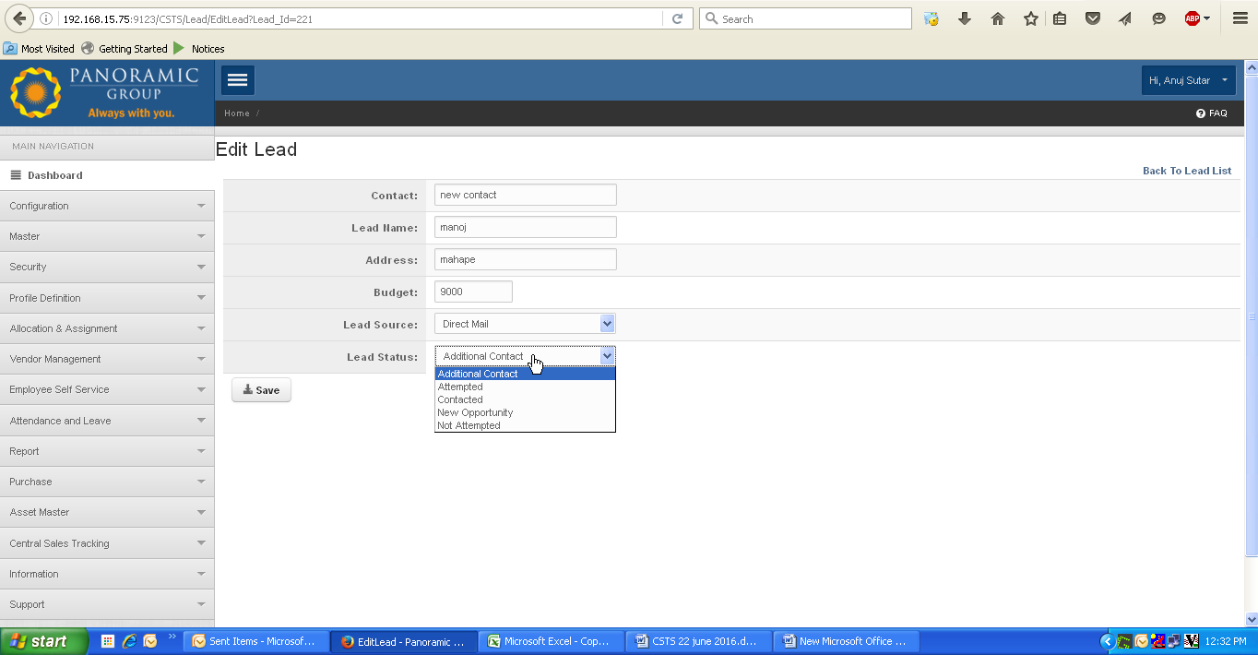

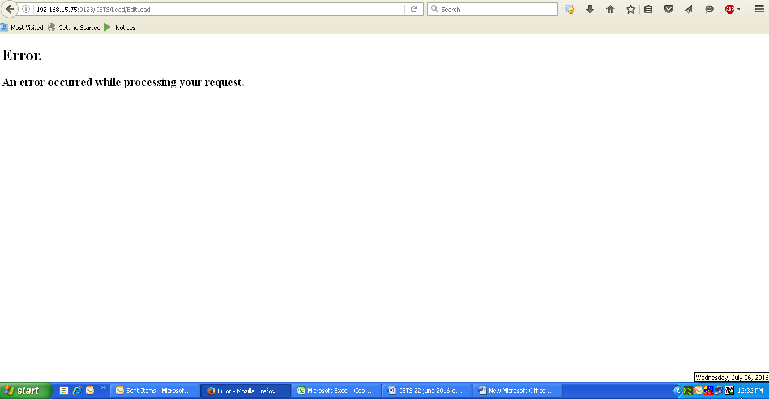

22. Application allow to create enquiry for disqualified lead

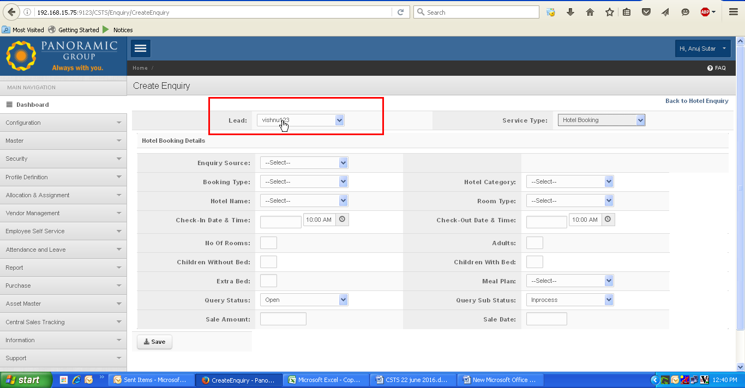

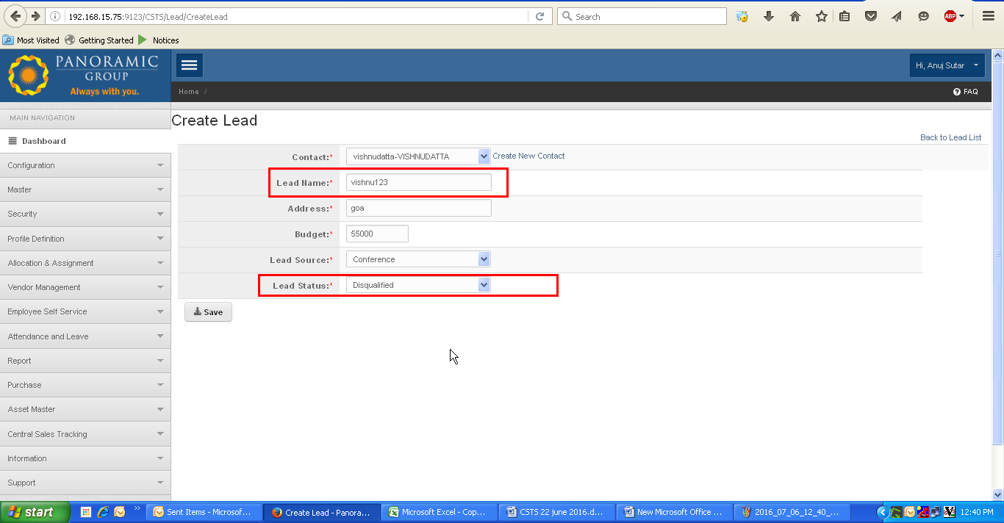

23. Payment receipt pdf generate blank page when user click on pdf, as shown

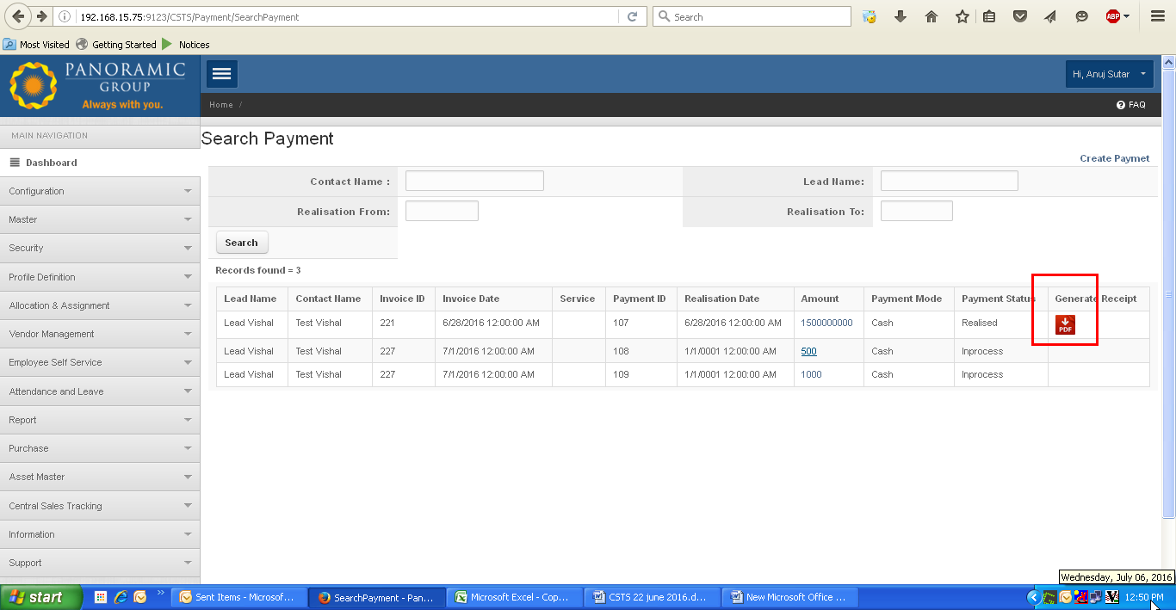

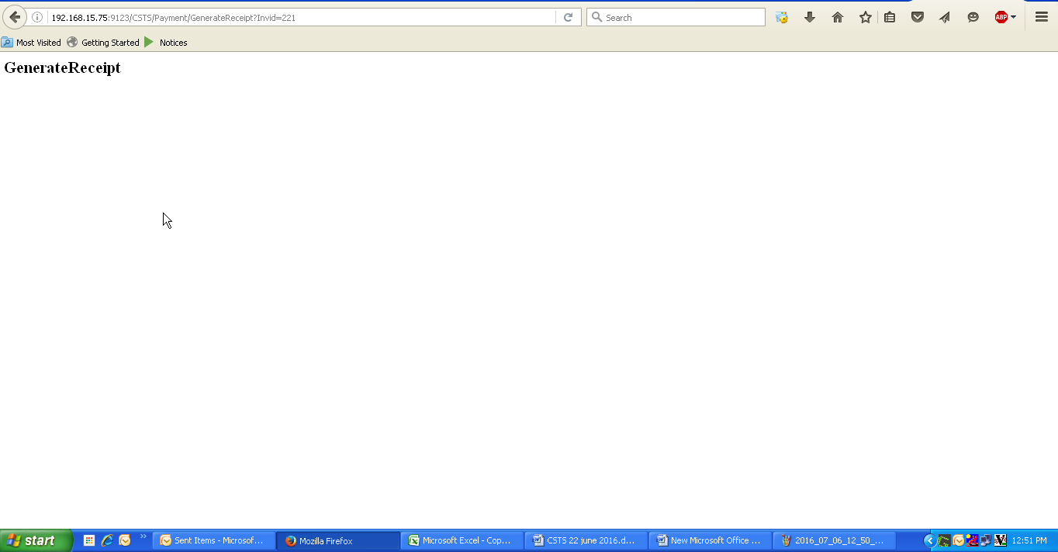

24. Payment List: For payment status “in process” when user tries to edit by clicking on amont hyperlink as shown , application redirects to “Edit payment” page where application displays “Realisation date” in wrong format as (1/1/0001) with “Payment bounce reason” dropdown .

